Class of 2018 Hoodies Order Form

Student Name:_______________________________________
Phone #______________________________________________
3rd Period teacher:___________________________________

COST: $30. each
Payment: Check to WCHS with phone number OR CASH

PAID BY____________________ Check #__________________

COLOR CHOICE for Hoodie: (BLACK OR WHITE)
Hoodies will have RED lettering

Color (BLK/WH) | Size  (S, M, L, XL) | Name on Back (PLEASE PRINT)
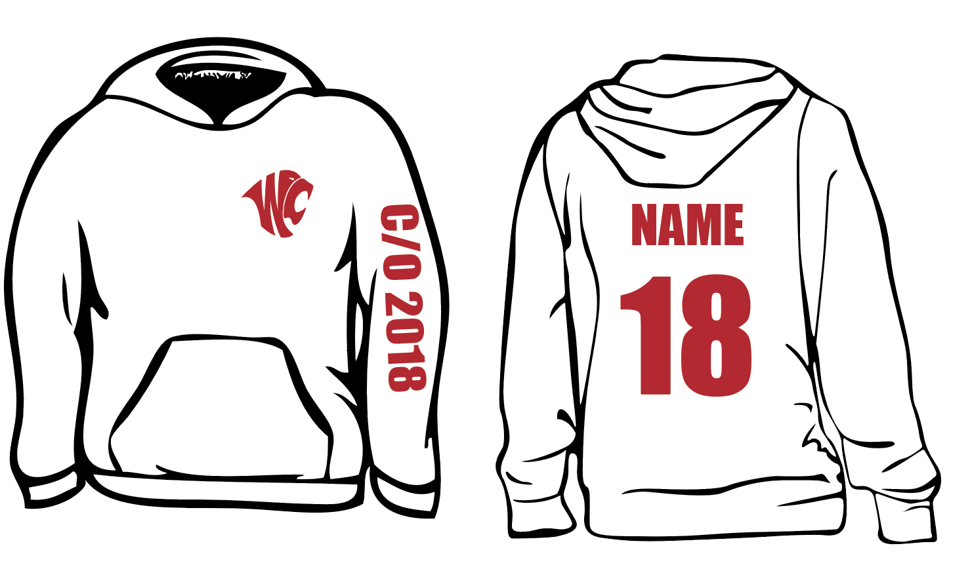
Return Order Form & Money to Mrs. Joiner or Mr. Stewart by 12/2/16

