Class of 2019 Shirt/Hoodie Order Form

Student Name: _____________________ Student ID Number ______________________
Phone Number: __________________ Third Period Teacher: ____________________

T-Shirts: $12. ($20. XXL-3XL)

Hoodies $30. ($32 XXL-3XL)
(Exact Change or Checks Accepted)

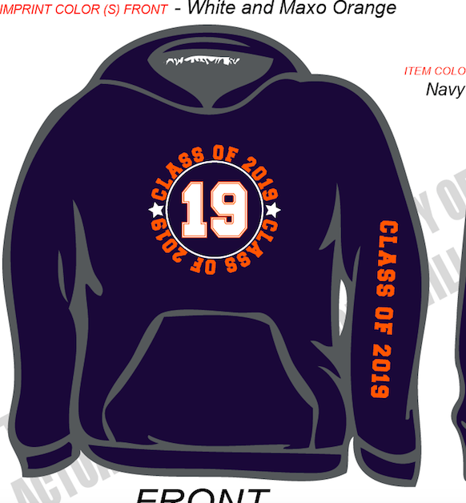

 | Small  ($15.00) | Medium  ($15.00) | Large  ($15.00) | X-Large  ($15.00) | 2XL ($18.00) | TOTAL COST
T-shirt
Hoodie

Name on Back of Hoodie (PLEASE PRINT CLEARLY)_____________________

ORDER TOTAL________________ Cash / Check # _______________

Turn in order forms and payment to Mrs. Joiner (Media Center)
PLEASE pay by October 6 @2:00PM
Feel free to e-mail your questions to: tjoiner@pasco.k12.fl.us

