AP European History Summer Assignment
Hello all and welcome to AP European History! I am very happy to be teaching the course and the journey we will be embarking upon this coming school year. This course will be challenging but quite rewarding. The information you learn in this class will better prepare you for the future and will further enhance your understanding of the world around us. We will begin our journey with the Renaissance and Protestant Reformation and conclude with recent developments on the European Continent. Our investigations will reveal the social, political, economic, intellectual, and cultural transformations on the continent – and beyond. Our discussion topics will include: religious conflicts, power struggles, the strengths and weaknesses of different political systems, the exploration of revolutionary ideas in the realms of art, economics, science, and politics. Because of the expansive scope of this course and the scarce time we will have during the academic year to gain such insights, it is absolutely imperative that we acquire meaningful insights over summer.
The following components will make up your summer assignment and will be due the first day of school:
- Read A Little History of the World by E.H. Gombrich (Available at Amazon or Barnes and Nobles).
- European Map Activities
If you have any questions about this assignment, please feel free to email me at kngarcia@pasco.k12.fl.us . It may take me a few days to respond, but I will get to your email (I will be out of the country the first two weeks in June and internet access will be spotty.)
I look forward to meeting you all in August

Katherine Garcia

Part I: Reading Assignment
Directions: You are to read the text. After each chapter, you are to answer the questions provided here. Some questions are very easy and some require more critical thinking. The idea is to be continuously thinking about history and improving our understanding. All answers need to be written in complete sentences. Please site, using MLA format, any sources (other than the text) used to help answer the ‘Research’ questions.

Chapter1:
- What is history? What do you think history is?
Chapter 2:
- How can we explain the deep past, before there were humans on earth?
- Define artifact. Give a few examples of prehistoric artifacts.
- What is the Heidelberg jaw? Where was it found?
- What is the name we give to early man? Why do we give him that name?
- Why is the Stone Age called the ‘stone’ age?
- Prehistoric man is known as ‘caveman,’ although they may not have actually lived in caves. These cavemen invented stone tools, but what else?
Chapter 3:
- Today there is a manmade dam on the Nile River. What is it called? Research the dam. How did it change Egypt?
- What is the type of writing that the Egyptians created?
- Which Pharaoh built the Great Pyramid?
- How did the Egyptians build the temples and pyramids?
- Describe two Egyptian gods.
- What is an obelisk? Are there any obelisks still standing today? Any located near you? If so, where?
- Why is the Sphinx in the shape of a cat?
- Explain the Egyptian’s burial rites.
- How do we know so much about Egyptian life?
- What is papyrus?
- Which empire lasted the longest – Roman or Egyptian?
- What is the pharaoh Akhenaton known for?
- Research controversies surrounding ancient art that has been ‘stolen’ from one country and put on display in a museum in another country. Did this happen with Egyptian art?
- Research the Rosetta Stone. What is it? Who found it, and where? How did it end up in the British Museum? How long did it take for scholars to decipher it?
Chapter 4:
- The Egyptians were not the only ancient peoples who we can now credit for things, but they are the most well-known. Another ancient people lived in Mesopotamia, which is a Greek word that means land between the rivers. Where was Mesopotamia located? What country is there today?
- Mesopotamia was located in a vast plain, crossed by two rivers, a land of heat and swamp and sudden floods. Here and there tall hills rise out of the plain. Are these hills just regular hills?
- What empires existed in Mesopotamia?
- What were the Sumerians like?
- What is important about the city of Ur, in Mesopotamia?
- What was discovered in the tombs of Ur?
- What is cuneiform?
- Who is King Hammurabi, and what is the Code of Hammurabi?
- What did the Babylonians and Assyrians worship?
- Who was Nebuchadnezzar? Why is he remembered?
- Gombrich writes that ‘in other languages such as French or Italian – most of the days of the week still belong to the planets that the Babylonians first names’ (Gambrich 20). What are the days of the week in Spanish? In French? In Italian? Do these words correspond to a planet, such as Mars?
Chapter 5:
- Why does Gombrich say that the Palestinians, the Jews, were ‘something special, that they didn’t just become a part of history, they made history’ (Gombrich 24)?
- What is the story of the Tower of Babel? Or what does it mean when people use the word ‘babel’?
- Who was King Solomon?
- What was located in the innermost part – the holiest part – of King Solomon’s Temple?
- To what event does the phrase ‘Babylonian captivity of the Jews’ refer?
Chapter 6:
- Another ancient people were the Phoenicians. What are the Phoenicians famous for?
- Where did the Phoenicians live? Where did they do their trading?
- Many Phoenicians stayed in their trading posts on foreign shores and built towns. Were they welcomed?
- Gombrich states that the Phoenicians did not feel cut off from their home and their families. Why?
Chapter 7:
- What did Schliemann discover?
- Schliemann found vessels and daggers in Greece. Where were these objects created?
- Explain the differences between Cretan and Egyptian art.
- Throughout the book Gombrich tells us things like ‘when the Greeks came to Greece, they weren’t yet Greeks.’ What does he mean by this?
Chapter 8:
- Who were the Persians? Where did they live? What did they worship?
- Who was Cyrus? What did he do?
- What amazing feat did Cyrus’ son Cambyses do?
- What king ruled the vast Persian Empire? How big were his lands? What did he want?
- Why is the Battle of Marathon famous? Why is it called ‘marathon’?
- What happened at the pass called Thermopylae?
- Who were the Spartans? What is the definition of the word ‘Spartan’?
- The Greeks were always outnumbered against the Persians, yet they persevered. What made the Greeks different than other peoples?
Chapter 9:
- What god did the Greeks honor at their Olympic games? What games were held?
- What prizes did the victors win?
- What happened at the Temple at Delphi? What was the shrine called?
- Greeks would make pilgrimages to the Delphi, to consult the god Apollo. How accurate was the Delphic Oracle?
- The Athenians had fewer reasons to be afraid of outsiders, but they lived by strict rules created by a leader named Draco. What does the word ‘draconian’ mean today?
- Democracy is an idea that its roots in Greek cities. In 594BC, King Solon introduced new laws. (This is the same time as when Nebuchadnezzar ruled.) What did Solon’s rules decree?
- Could anyone become a citizen, and vote with the majority?
- The word ‘politics’ derives from Greek. What does it mean?
- What did Athenians do with their rulers who showed signs of acting like tyrants?
- Who was Pericles? What is his claim to fame?
- Gombrich writes that the Athenians began to think about things in a new way, and they also saw things differently. What are the new ways in which they were thinking? What new style of art did the Athenian artists create?
- Find a picture of the Acropolis and study it. What is noticeable about the architecture – something that we might take for granted, but that the Greeks invented and perfected?
- The Athenians perfected the art of poetry, and they also created a new form of literature. What was it?
Chapter 10:
- When was the city of Mohenjo Daro discovered?
- What does ‘Indo-European’ mean?
- Explain the caste system in India. Does it still exist today?
- Who is Brahma in Indian religion?
- Explain Prince Gautama, and how he became the ‘Buddha.’
- What was Buddha’s ‘Moment of Enlightenment’?
- Do people practice Buddhism today? Where is Buddhism practiced as the predominant religion?
- Make a list of all the things you want – for your birthday, for example. Cut the list down to five things. Down to one. Take note of how you feel as you cut back on your desires, as you rein them in, so to speak. Do you feel more in control? Are you more peaceful?
Chapter 11:
- What kind of writing did the Chinese do?
- Who was Confucius? When did he live?
- What was Confucius’ goal?
- What was the most important thing for Confucius?
- Who was Lao-tzu and what did he preach? What is the Tao?
Chapter 12:
- Who fought against each other in the Peloponnesian War? Why is it called that?
- What did the Macedonians plunder during the Delphic War?
- When King Philip was assassinated, his 20 year-old son Alexander took command of all of Greece and Macedonia. Why was he ‘no ordinary boy’?
- Who was Alexander’s teacher?
- Why is Aristotle so revered?
- How did Alexander figure out how to ride his horse, Bucephalus? What does this story say about Alexander?
- Alexander’s popularity flourished and his troops marched on Persia, conquering Asia Minor. In Asia Minor Alexander came upon the Gordian Know. What can you find out about this famous tale?
- Does the Gordian Knot story remind you of any other heroic tale? Which one? Why?
- Study the map on pages 70 and 71. Compare the map to a modern-day map, so you can see which countries Alexander traversed and conquered. Explain your comparison.
- In your opinion, what was one of the best things that Alexander did?
Chapter 13:
- What peninsula did Alexander leave alone?
- What is the story of how Rome was founded?
- Who fought in the Punic Wars? What does the word ‘punic’ signify?
- Who was the Carthaginian soldier who traveled with war elephants?
Chapter 14
- Who was the ‘Enemy of History,’ the book burner from China?
- Who built the Great Wall of China? How many miles does it stretch?
- Why did he build the Wall?
- Find the Great Wall of China on a map and trace its path. Using an aerial space map, see if you can find the Great Wall. Is there any other man-made creation you can see from space? If so, what is it?
- Gombrich writes: ‘If you want to do anything new you must first make sure you know what people have tried before.’ What does Gombrich mean by this statement?
- Gombrich points out that China is the only country in the world to be ruled for hundreds of years by who – not soldier, nobility or even priests. By who?
- Emperor Han took the throne following Shih Huang-ti’s death. He was unlike Shih Huang-ti in one very important way. What was it?
Chapter 15:
- The Romans did not try to turn the lands they conquered into a single, vast empire as Alexander did. What did they do instead?
- Why did the Romans build so many roads?
- What is an aqueduct? Why did the Romans build them?
- Research and identify Roman towns in the British Isles that did not fall into ruin and still exist today. What buildings or roads are left? Does any part of the Roman Wall still stand? Any bathhouses?
- What is the difference between Roman and Greek sporting events?
- What is a gladiator?
- Who was the most popular Roman general?
- Define ‘Romance languages.’ From where does this name derive?
- Today we use an everyday object that can be credited to Caesar. What is it?
- Who murdered Caesar? Who came to power after him?
- The Roman poets during Augustus’ time are the most famous of all Roman poets. These poets were influence by Greek poetry, which ‘was lucky for us, for if they hadn’t, we might never have heard about any of it’ (Gombrich 91). Name at least one poet and describe a few of his works.
Chapter 16:
- What did Jesus teach?
- Why was Jesus put to death on a cross?
- Who was the Apostle Paul?
- The Apostle Paul’s word struck a chord with the ‘poor and downtrodden’ people. What did he say that was so enlightening to them?
- How did the Romans react to Paul’s teaching?
- Who was the Roman Emperor Nero? What was he like?
- What did Nero blame on the Christians?
- What was the significance of the Roman Catacombs?
Chapter 17
- How did wealthy Romans live?
- Describe a Roman Bath.
- What was the Colosseum? What was it used for?
- Many ruins survive in Rome alone. Research and identify the various ruins. Which were built by Trajan? By Nero? Caesar?
- How did the Germanic tribes live?
- What were the Limes?
- Emperor Trajan conquered Dacia, what is now Hungary and Romania, in AD 133. Once Dacia became Roman, its inhabitants spoke Latin. What was it then called?
- Which Roman emperor decreed that Christianity be the state religion? Why?
- Constantine no longer ruled the empire from Rome because the chief threat to the Roman Empire came from the east; the Persians were once again a powerful force. From what city did Constantine rule?
Chapter 18:
- Who were the Huns? How did they fight?
- What happened to the Roman Empire during the period known as the ‘Migrations’?
- Who was Attila the Hun?
- Who was the last Roman emperor? What is the ‘curious coincidence’ about this name?
- The year 476 marks the end of the Roman Empire together with the long period we call ‘antiquity.’ It also marks the birth of a new era, the Middle Ages, given its name for no other reason than that it falls between antiquity and modern times. Gombrich notes that at the time, no one noticed that a new era had begun. Is it possible to notice when a new era has begun? What ‘birth of an era’ type moments can you identify?
- What is the name of the large church Emperor Justinian built in Constantinople?
- Name the laws Justinian collected.

Chapter 19:
- What is signified by the term ‘Dark Ages’?
- Who was Benedict?
- What did Benedictines do?
- Were any monasteries built on the British Isles?
- What did the monks teach the people in Germany how to do?
- What does Gombrich mean when he states that ‘the work of writing was also that of ruling’?
- Was paganism still practiced?
Chapter 20:
- Who was Muhammad?
- What is Muhammad’s Emigration?
- What is the Islam paradise like?
- What is the Koran? What does it teach?
- Muslim terrorists attached the USA on September 11, 2001. The terrorists are said to have taken Muhammad’s words as absolute truths – that to kill is not sin, and heaven is a luxurious paradise awaiting anyone who kills ‘infidels.’ What does this tell you about ‘blind belief’ and religion? Explore religious extremism in other parts of the world, and in other religions. What did you find?
- The Arabs attacked Cyprus, Sicily, Africa, and Spain, and in 670 the city of Constantinople withstood a seven- year siege. Did the Arabs preserve the Greek scrolls, as Alexander did?
- Who finally defeated the Arabs?
- Were the Arabs interested in other cultures?
- What did the Arabs invent?
Chapter 21:
- Who was Charlemagne? What does his name mean?
- What was Charlemagne’s goal? How did he go about it?
- Was Charlemagne interested in education?
- What happened to his kingdom after Charlemagne died in 1814?
- What happened to his schools?
Chapter 22:
- Were the German peasants who worked the fields at this time free men? What were they called?
- How were the noblemen granted their land?
- Why did Henry IV of Germany have to ‘go to Canossa’? What does it mean today when someone says he has to ‘go to Canossa’?
- What happened in 1066?
Chapter 23:
- What does the word ‘chivalry’ mean?
- How did one become a knight?
- Explain the steps for becoming a knight?
- What was it like to be a knight?
- Describe a medieval castle.
- Research medieval castles. How many of these fortresses are still standing? Where?
- What were Crusades? Who was Godfrey of Bouillon?
Chapter 24:
- Who was the German emperor with the fiery red beard?
- Describe the dubbing feast of Mainz.
- During the Third Crusade, three kings traveled to Jerusalem. Barbarossa was on king; who were the other two?
- Barbarossa’s grandson Frederick II of Hohnestaufen had a rather famous guardian. Who was it?
- What was the Magna Carta?
- As German Emperor Frederick II was a highly likable fellow and everywhere he went he won over the local princes – he did this in Sicily and in Germany. How did he win over so many different people?
- Who was Genghis Khan?
Chapter 25:
- Describe ‘life in a town or city’ in the Middle Ages around the year 1300.
- Craftsmen such as tailors, shoemakers, drapers, bakers, locksmiths, painters, stonemasons all belonged to guilds, or associations. Guilds were difficult to enter and had strict rules. Explain the career path of a craftsman.
- How were large churches or cathedrals conceived and built?
- How did the Jewish people fare in these European medieval towns?
- What are some of the differences between how people lived in France and how they lived in Germany?
- What does the phrase ‘Babylonian captivity of the Popes’ refer to?
- Which countries fought in the Hundred Years War?
- Who was Joan of Arc? How does she fit into the Hundred Years War?
Chapter 26:
- What was the Renaissance?
- Who was Leonardo da Vinci? What did he do that was so daring?
- Leonardo is one of three Italian artists who are traditionally considered the masters of the Renaissance. Name the other two. What are their most famous works?
- Who were the Medici family?
- Who invented the printing press?
- Who was the so-called ‘last-knight’?
Chapter 27:
- What did Christopher Columbus long to do?
- Christopher Columbus was Italian, but which queen gave him ships?
- What land did he discover?
- What happened to Columbus?
- What was the goal of the Spanish conquistadores?
- What is a hypocrite? What is a religious hypocrite? Do people still act this way? Give examples.
- Who was Hernando Cortez? What did he do?
- Who was Montezuma? What happened when Montezuma and Cortez met?
Chapter 28:
- The two Medici popes in Italy were different than other popes. Were they interested in the word of God and salvation?
- How did the Medici popes raise the money needed to rebuild St. Peter’s Church in Rome?
- Who was Martin Luther? What did he become angry about? How did the printing press help his cause?
- What is the Reformation?
- What happened in Worms, Germany?
- What did England’s King Henry VIII do that has made him famous for all time?
- What did Henry VIII’s marital problems have to do with religion?
Chapter 29:
- Ignatius of Loyola was a Spanish knight who was wounded in one of the wars between Charles V and Francis I. After he recovered, he devoted his life to the Catholic Church. What Christian society did he found?
- What reforms did the Jesuits wish to achieve during the Council in Trent?
- What did King Philip II of Spain do to people accused of heresy?
- Describe the fight for power between England’s Queen Elizabeth I and Mary, Queen of Scots.
- Spain’s King Philip II retaliated against Queen Elizabeth and England with what famous navy?
Chapter 30:
- The Defenestration of Prague began when what happened?
- Describe the Thirty Years War.
- Fear of witches and witchcraft spread through much of Europe. What happened to the women accused of being witches?
- The Laws of Nature were just being understood and explored. Name the Italian man who first applied mathematic calculations to things in nature.
Chapter 31:
- What did the English do to their king, Charles I?
- Cromwell died in 1658. The Royalists returned to power, and put Charles II on the throne. What was this time called?
- France became the dominant country after the Thirty Years War. How did this occur?
- Which French king called himself the ‘Sun King’?
- Louis XIV took all the powers the Richelieu, leaving his noblemen little to do. What did he command them to do?
- Describe life at the court of Louis XIV. Research Versailles, and describe the clothes noble people wore.
- Where did Louis XIV get all the money he needed to live so lavishly?
Chapter 32:
- What was the Turkish symbol?
- Which country threatened the Turks?
- In 1580 there was a Russian czar who made Nero look mild. Who was it?
- In 1689, six years after the Turkish siege of Vienna, Peter the Great cam to the throne as Czar. Peter the Great was barbarous, cruel, fond of drinking and violent, like his predecessors, but he had a goal for Russia. What was it?
- Did Russia have sea ports?
- What was the name of the first sea port Peter the Great had built?
- What clothing changes did Peter the Great enact?
- In 1714, news reached the Swedish Charles XII in Turkey that his subjects were going to elect a new ruler. Legend has it that he made an extraordinary journey. What was it?
Chapter 33:
- During the Eighteenth Century, people had views and opinions far different than the ones we have today. Name a few of those differences.
- The principle of tolerance was not widespread, but it was gaining attention. Is tolerance embraced today? How or how not?
- What are the three fundamental principles of the Enlightenment?
- What did Frederick the Great abolish?
- During this time in America, the inhabitants of the British colonies were refusing to be British subjects. Who were the leaders in the American fight for freedom?
- Name the ‘Founding Fathers’ of the American Revolution. What did they do for their cause?
- When was the American Revolutionary War?
- What year did America declare its rights? What are they?
Chapter 34:
- What country did Catherine the Great rule?
- Research the reign of Catherine the Great. What reforms did she push? How was she viewed by her subjects?
- The Sun King’s successors, the French Kings Louis XV and Louis XVI, did not subscribe to the Enlightenment. What was life like in the court and in France during the reign of Louis XV (1715-1774) and Louis XVI (1774-1792)?
- In 1789 the French Bastille, the jail, was stormed. What caused the people to do this?
- Discuss the French Revolution. Why was there a period called the ‘Reign of Terror’?
- How did the supporters of the French Revolution dress?
- What was the French Revolution supporters’ rallying cry?
- Who were two leaders of the French Revolution?
- When was the Revolutionary Tribunal abolished?
Chapter 35:
- Gombrich reminds us that the best part about history is that it is all true – all these amazing things actually happened. Is history interesting to you? Why or why not? How can historical studies be made interesting?
- Discuss some of Napoleon’s early feats.
- Britain was a powerful country, with colonies in America, Africa, India and Australia. Napoleon knew his army was too weak to attack Britain directly. What did he do instead?
- There is a legend that says Napoleon’s men used the Sphinx for target practice, shooting off and damaging its nose. Is this true? Research and explain your conclusion.
- In London, there is a famous square named Trafalgar Square. Who does it honor, and why?
- Napoleon was not crushed until the famous 1815 Battle of Waterloo. Which army did Napoleon fight this time?
Chapter 36:
- Many machines were invented in the mid-Eighteenth century. Who invented the steam engine? When?
- Who invented the steamboat? On what river was it first launched?
- When was the first steam locomotive invented?
- Who invented the telegraph?
- How did machines change people’s lives? Was it a change for the good?
- Who was Karl Marx? Describe the Socialist Movement.
- What was Marx’ Communist Manifesto?
Chapter 37:
- The British wanted to trade with China. Did China agree to this?
- Describe the Taiping Rebellion.
- Why did the Europeans (British and French) attack China?
- Why does Gombrich call the Japanese the ‘best students’ in all the history of the world?
- What was going on in the United States during this time (1820s)?
- What caused the American Civil War?
Chapter 38:
- What were the three most powerful countries in Europe after 1848?
- What about Spain, Turkey and Italy?
- What did Bismarck, as chancellor of the unified German empire, do for Germany?
Chapter 39:
- Why did European countries strive to own colonies?
- How did the Europeans treat the native inhabitants of the colonies?
- What colonies did Britain own?
- How did World War I get started?
- Once Germany was in the war, all ancient enemies were unleashed. Which countries were known as the ‘Central Powers’ in WWI?
- Describe Trench Warfare.
- Research World War I. When did the various countries get involved? What was gained? Lost? How many people died in World War I?
Chapter 40:
- Below is a list of some world events since Gombrich’s death. Research two of these topics. Provide a short summary, including your opinion.
  - JFK
  - Korean War
  - Vietnam War
  - Man on the Moon
  - Berlin Wall
  - Gulf War
  - Iraq War
  - Afghanistan War
  - September 11, 2001
  - War on Terror
  - Darfur
  - World Hunger
  - Torture
  - Hurricane Katrina
  - AIDS
  - Immigration
  - ISIS
- Create a timeline of 20 major events from this book. Analyze these events and summarize why you believe they were pivotal to European History.

Part II: European Map Activities
Directions: You are expected to have a general working knowledge of the geography of Europe before we begin our studies. Please complete the following maps according to the directions. Maps should be completed and colored neatly—bodies of water blue, countries in varying colors. Use a key when necessary. You will keep these maps in your binder throughout the year.

Complete one map for each of the following:

A. Modern Europe: Political (countries)
B. Modern Europe: Cities
C. Bodies of water & mountains
D. Europe in 1914 countries only
E. Europe in1815 – countries only
F. Europe in 1648 – countries only

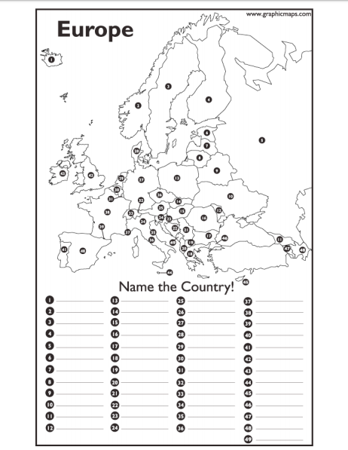
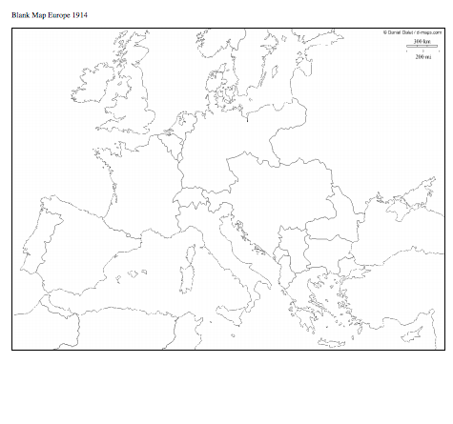

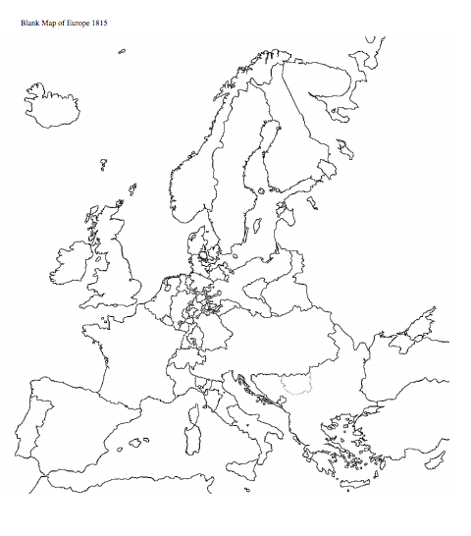

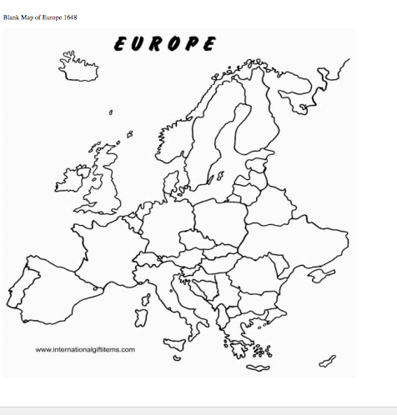

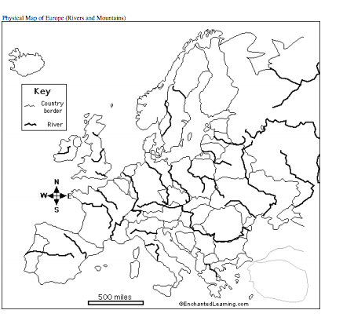

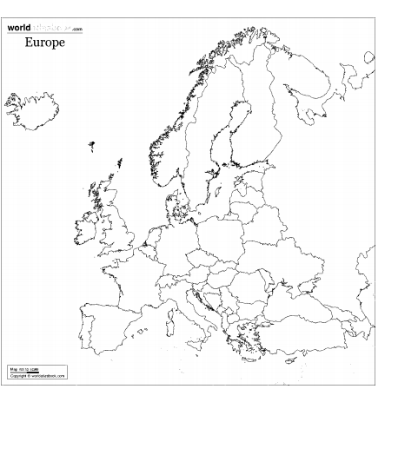

Reminders for maps:
• Be thorough and neat
• Please use color when needed
• Provide a key (it may be easier than writing in the small spaces encountered on a map of Europe.
• These maps will be a resource for you throughout the year
• Map quizzes may occur!

